# Tender Notice for Sale of Existing Abandoned Containerized Office

# at Pipavav Port

The Gujarat Pipavav Port Limited invites sealed tenders from reputed purchasers for **Sale Out of Existing Abandoned Containerized office** located at BOD area

Interested Purchasers should inspect & satisfy themselves regarding condition of this Containerised office before participating in tender process. The containerized office is being sold on **“As is where is basis” and “no rejection basis”** only. The rates quoted should be exclusive GST and other taxes if any. The offer should be sent on or before date 08.08.2025 up to 3.00 PM email to narendra.rawal@apmtemrinals.com.

|  |  |  |
| --- | --- | --- |
| **S. No.** | **Particulars** | **Details** |
| 1. | Name of the Firm |  |
| 2. | Name of the Authorized person, his designation & Contact Number |  |
| 3. | Office Address |  |
| 4. | PAN Number (Attach photocopy) |  |
| 5. | GST Number  (enclose GST Registration certificate if registered) |  |
| 6. | **Offer for Purchase of Abandoned Containerised Office located in BOD area** | Rs……………… + GST  (Rupees…………………… |

Seal & signature of the tenderer

**TERMS & CONDITIONS:**

1. The rate quoted should be exclusive of GST and all other taxes if any.
2. The sale is “**as is where is basis**” and the highest bidder has to make payment and take existing abandoned containerized office immediately without any rejection. All the items are available for inspection during the working hours from Monday to Friday at Pipavav Port.
3. Bidders should inspect & satisfy themselves regarding quantity & quality and condition of items before participating in auction in every manner. No complaint or dispute of any kind shall be entertained from their participation once the tenders are opened and the Buyer shall not be allowed to withdraw.
4. The successful bidder shall submit full payment within 15 days from the date of confirmation of order by APM Terminal Pipavav. After the full payment, bidder will have to take out the said Containerised office within 15 days from site. If this is not done in time, GPPL will levy charge Rs 5000 per day basis.
5. During the dismantling, loading activities, the successful vender shall strictly follow up APM Terminals Pipavav Safety guidelines and Port security rules.
6. If required any permission from local OR state government shall be responsible for successful bidder and cost shall be borne by bidder.
7. All expenses such as dismantling, equipments, tools & tackles, stacking & de-stacking, transportation, loading, unloading, consumable, electricity, Personnel protective equipments form manpower, Manpower, Insurance etc and any other expenses shall be borne by the buyer.
8. After the takeout Containerised office, the area shall be proper level, clean and hand over to APM Terminals Pipavav.
9. if any Assets of APM Terminals Pipavav will be damage during the dismantling, loading, unloading, taking out of containerized office activities, the cost of said damage repairs into as original conditions shall be borne by Vender.
10. The APM Terminals Pipavav shall reserves its right to accept/reject the submitted any tender/offer without any reason. The decision of the GPPL in this respect shall be final and binding on the buyer.
11. The sale is subject to Amreli jurisdiction only.

**EXISITNG ABANDONED CONTAINERISED OFFICE 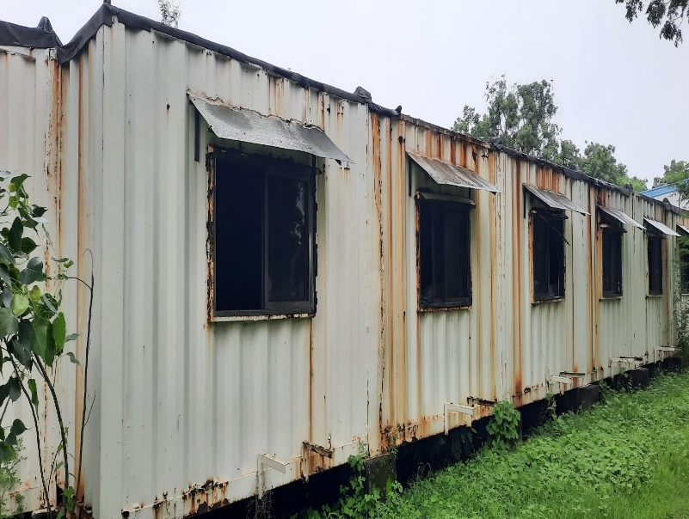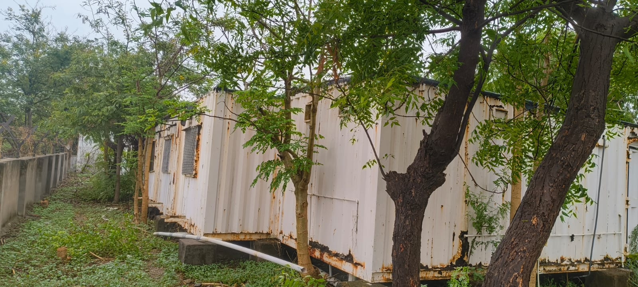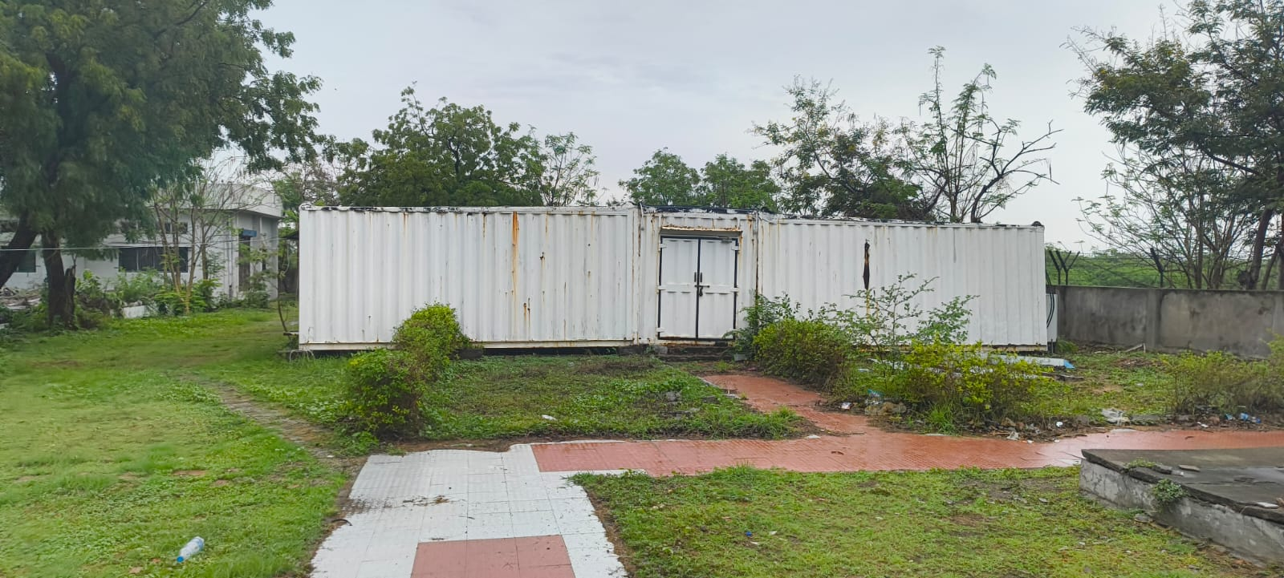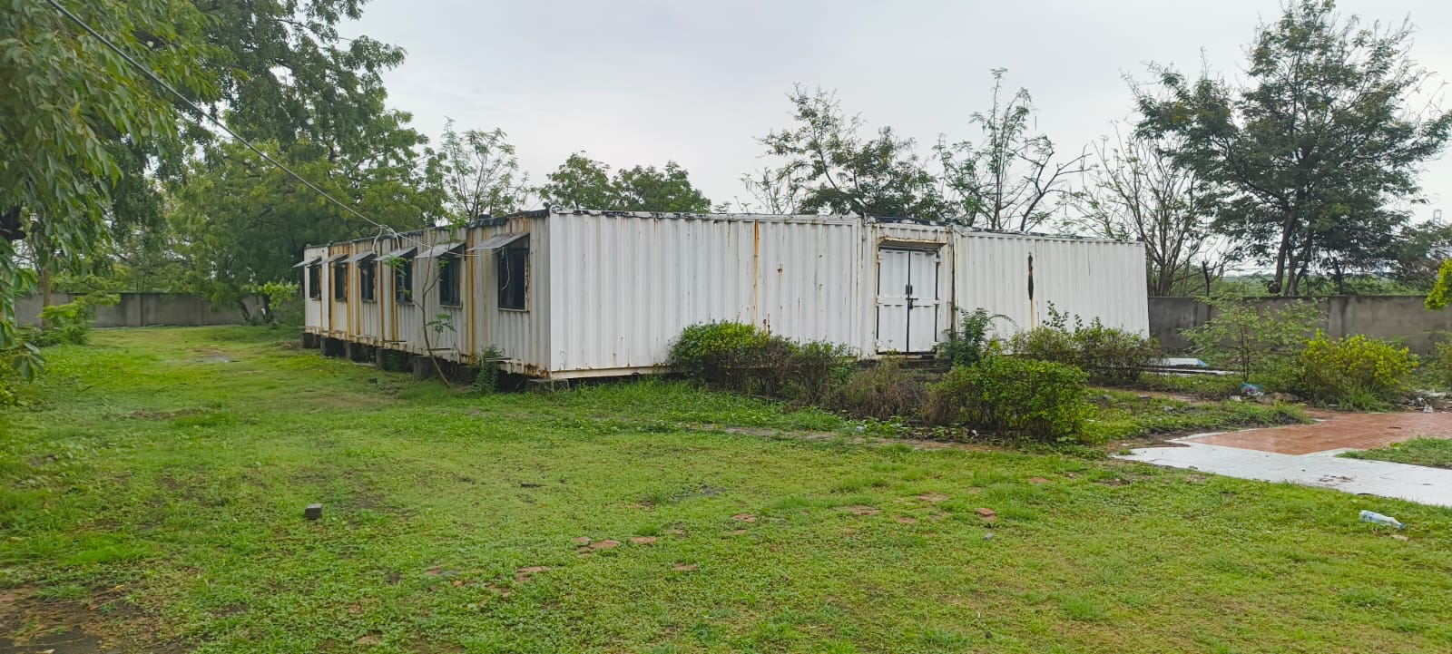AT BOD PHOTOGRAPHS**